IFG Explore 2nd Year
Term Two – Week Six Night Sky Adventure

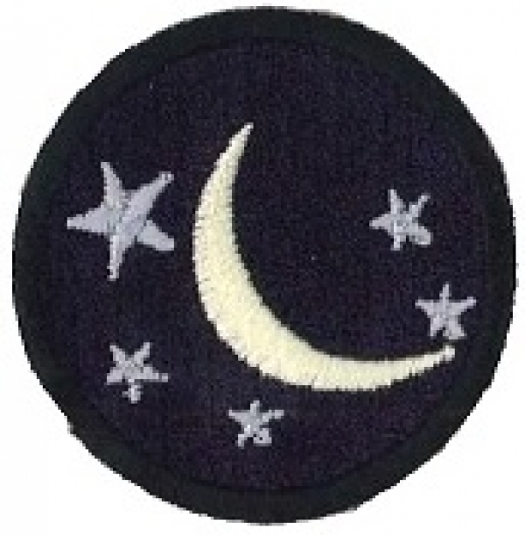
Aim: The purpose of this Award is to give the girls an opportunity to learn about the night sky

Objective:
- Learn about the stars and the moon
- Make a Star mobile

Preparation:
Gather materials for activities/game:
- Yellow construction paper - Stones painted silver
- String or yarn - Memory cards “Day and Night”
- 2 plastic straws - Black construction paper
- Scissors - Paper
- Pencil - Glitter
- Eraser - Glue
- Stapler - Aluminium foil
Pre SetUp:
Arrange an area for girls to make their mobile including tables to work on.

SetUp:
Usual set up and roll call.

Devotions:

Genesis Chapter 1
On the first day of creation, God said, “Let there be light.” And there was light. He called the light the name we use now - - day. And the darkness He called night, just as you and I do.
On the fourth day, God made the sun, moon, and stars. He said, “Let there be light … to divide the day from the night; let them be for signs and seasons, and for days and years.” The greater light He made to rule the day – our sun. The lesser one He made to rule the night - - our moon. Just think of God’s great power that He could put the sun, moon and stars into the sky and make our earth turn for night and day.
Use props (Florescent Stars) to show girls what it would be like without the stars and the moon at night. Talk about how good it was that God created the division between night and day and put in a moon and stars to give some light to our Night sky.
Prayer: Thanking God for the creating our world and all that is in it.

Teaching Session:
Mum, why do stars twinkle?” Or, “Where did the moon go?” Or, “Is Mars further away from Pluto?” How about, “How can I get to Venus? Are there aliens there?” Okay, we don’t have all the answers but we do have some ideas to get you started. Checking out the night sky is as easy as grabbing a flashlight, finding a spot on the grass and looking up.
What is a star?
A star is a big ball of gas that changes color and size over billions of years. On any given night, up to two thousand stars light up the sky – each one unique in shape and form. You can see stars best on a clear night in a dark spot, away from bright lights.
You can also see a star during the day. The sun is the brightest and biggest star in our universe—and probably the one that kids are most familiar with. This five-billion-year-old star is easy to spot, which makes it a great place to begin when teaching your kids about star gazing. If you’re an early riser, watch the sun rise in the east. The whole process takes about a half hour and engages your child with cool colors and a first look at the gradual transformation from night to day. If you’re more of a night owl, the sun sets in the west so you and your child can watch the reverse process together when the sun goes down.
Moon Facts
From one of the most popular children’s bedtime books of all time, “Goodnight Moon,” to the sung-in-every-pre-school room, “Zoom, Zoom, Zoom, We’re going to the moon,” the fascination of this nighttime marker puts the moon on every night sky exploration list. To start, tracking the moon phases can be lots of fun—especially for the younger ones. For the older kids, tracking the moon phases can help them make a scale model for science class or compare where the moon is in relation to Earth and the other planets.
Here are a few moon facts:
- The moon is about one-quarter the size of our planet.
- It is the only moon on Earth and it’s one of the biggest in the whole solar system. Due to its small size, objects weigh less on the moon than they do on Earth.
- Neil Armstrong and fellow astronaut Buzz Aldrin left the Apollo 11 command module (piloted by Michael Collins) in orbit and performed a landing in the lunar module Eagle. Armstrong announced to a watching and waiting world that “The Eagle has landed.”
- Six-and-a-half hours later, he stepped onto the powdery surface with the words, “That’s one small step for man, one giant leap for mankind.” Aldrin soon followed Armstrong down the ladder to become the second man to stand on the moon.
- There are over 500,000 craters on the moon that can be seen from the planet Earth.
- Flying once around the moon is the equivalent of a round trip from New York to London.
- The moon changes its shape as it travels around the planet and takes 29 days to go through all its phases.
What to watch for: Moon Phases
Kids love learning about the phases of the moon because unlike stars, they can see and track the changes as they unfold. In the period of 29 days, they can chart all four phases of the moon just by looking up at the sky.

Games:
Moon Rock Toss
Paint several stones or rocks with a silver, shimmery paint. Set up a ring toss outside by moulding rings of various sizes out of tinfoil and placing them on the ground. Have the party goers stand back several feet and see how many of the rings they can toss their "moon rock" into. Determine points based on distance and how small or large the rings are. Calculate total points scored to declare the winner.
Memory game
Make cards out of black construction paper. On one side write different word "Night" or "Day" with a white crayon making equal number of "day" and "night" cards. I told the kids God Created night and day and so they had to match one "night" and one "day" card for fun. This was on a card table so they could all gather around it.

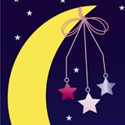
Activities:
Star Mobile
Equipment needed:
- Yellow construction paper
- String or yarn
- 2 plastic straws
- Hole puncher, Scissors, Pencil, Eraser, Stapler
Instructions:
- Draw 6-8 stars on the yellow construction paper. Each one should be a different shape or size.
- When you’re finished, ask a parent to help you cut out the shapes. Cut around the outside of the lines and then use an eraser to remove the pencil marks.
- Parent Alert: Using the hole puncher, pierce a hole at the top of each star.
- Cut a piece of string for each of the stars and tie it around the hole. Tip: Vary the length of the string to help your mobile come to life.
- Parent Alert: Pick up two straws and make the shape of the letter “X” with them. Staple the straws together where the two meet.
- Cut and tie a long piece of string to where the staple is and then tie the rest of the strings to one of the four limbs of the X.

Glittering Galaxy
Girls can create a sparkling galaxy using black construction paper, glue and glitter.
On the piece of black paper, instruct girls to roughly sketch their "galaxy." An idea for a galaxy shape is a spider: a central body with several "legs" coming out.
Trace the outline with glue, and sprinkle glitter over the glue.
Allow to dry before shaking off excess glitter. Voila--a new glittering galaxy!
Closing Prayer

Notices:
Hand out notices with the necessary information for next week’s visit to the planetarium if you have one in your area or a person in your area who watches the night sky through a telescope.

Home

IFG Explore 2nd Year
Term Two – Week Seven Night Sky Interest

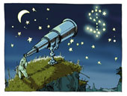
Aim: To look at, and learn about what else we can find in the night sky.

Objective:
- Visit a planetarium or person who observes the Night sky through a Telescope

Preparation:
- Make arrangements for transport for the visit.
- Equipment needed for activity on return to hall
- Aluminium foil
- Medium-sized box
- Glass bowls
- Flashlights
- Scissors
SetUp:
- Mark rolls before leaving for the visit.
- Set up tables for activity on returning to hall

Devotions:
Your choice tonight or you may just want to open with prayer.
Activity:
Equipment:
- - Aluminium foil
- - Medium-sized box
- - Glass bowl
- - Flashlight
- - Scissors
Instructions:
- Fill up two thirds of the glass bowl with water and set it aside.
- Cut a piece of cardboard from the box. Make sure it is big enough to fit underneath the bowl.
- Cut small pieces of aluminium foil and shape them into little stars.
- Place the stars on top of the cardboard.
- Place the glass bowl on top of the cardboard and turn off the lights.
- Shine the flashlight on the bowl.
- Tap the bowl and see what happens to the stars when the water moves.
Explanation:
When you shine light on aluminium while water is moving, the light travels through the air and makes the aluminium stars twinkle. Similarly, when the star light moves through the Earth’s atmosphere at night, the air it passes through makes it appear to twinkle.

Closing Prayer:
Notices:
Home:

IFG Explore 2nd Year
Term Two – Week Eight Night Sky Interest

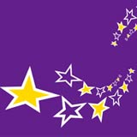
Objectives:
- Play Night Sky games
- Have an assortment of activities related to Night Sky

Preparation:
- Gather materials needed for activities/games

Pre SetUp:
- Set up area for activities

SetUp:
Usual set up for roll call etc.

Devotions:
Following the Star by Shepherds and Wise Men

Game:

Musical Planets
Using chalk, draw the planets on a driveway. While it would be impossible to draw them to scale, try to draw them as accurately as possible. Make Earth and Mars smaller. Give Saturn rings and Jupiter moons. Include Pluto if desired.
Just like musical chairs, play music and instruct the children to get on a planet when the music stops. Every time another round begins, announce that another planet has left orbit and take away a planet by covering it with cardboard or a piece of fabric. This game familiarizes children with the names of the planets.

Activities:
Space Rocket
Equipment:
- Paper towel tube - 1 sheet white construction paper
- Silver foil - Red and yellow tissue paper
- Small cardboard box - Round lid
- Glue - Pencil
- Ruler - Scissors
- Scotch tape
Instructions
- Cover the paper towel tube with silver foil and set it apart.
- Place the construction paper under the round lid. Trace a circle with your pencil and then cut it out. Cut a slit from the edge of the circle to the centre.
- Overlap the edges of your circle so that they form a cone. Tape the cone and cover it in tin foil.
- Pick up the silver tube and glue the cone to the top of it.
- Use your cardboard box to cut out 3 triangles. Wrap them in foil and glue all three to the rocket. Be sure to space them out so that one is on top and the other two are on the sides of the rocket.
- Cut strips of the tissue paper and paste them onto the bottom end of the rocket. Now, you’re ready for lift-off!

Activity Two:
Colouring In Sheet – Planets
Attached

Solar System Model
Every girl should have the opportunity to create a model of the solar system. Gather foam balls in a variety of sizes to simulate the sun and the eight planets (nine if you count Pluto). Alternatively, children may cut circles from cardboard to represent the planets instead of using foam balls.
The largest circle should be the sun. The sun is vastly larger than any of the planets in real life, but for this craft just make sure that the sun is the largest. Uranus, Jupiter, Saturn and Neptune can be made slightly smaller than the sun. The other planets are smaller still. Add rings to Saturn (these can be made from paper or pipe cleaners).
Game to Finish:
Smashing the Sun/Moon Piñata
Prepare beforehand
Equipment- 1 round balloon, Newspaper, Paste/glue, Dark Blue, and yellow poster paint,
String, Scotch tape, 2 medium bowls, Paint Brush, Scissors, Sweets.
Instructions:
- Cut the newspaper into long, narrow strips.
- Blow up the balloon. Then, use the other bowl to rest the balloon on while you are working.
- Dip the newspaper strips into the paste mixture and cover the balloon with at least four layers of strips.
- When you're finished, let it to dry overnight.
- Once it’s dry, pop the balloon by cutting a small hole at the top with scissors. Use one end of the scissors to pop it. You can use that hole to fill your planet piñata with candy once you’re done.
- Tape a piece of string to the top of your new Earth piñata.
- Use your brush to paint the planet’s surface and then hang it somewhere to dry.

Closing prayer

Notices

Home

